Market Research Summary

Methodology

Firstly, I separated the data into rows that had individual offers, and the respective selling price of that particular item.

I then set about categorizing the selling prices into 3 distinct bins, which would help group the data and examine trends more easily. These groups are categorized as Low, Med, and High prices where “Low” prices for this data set lie between $5 and $11.67, “Medium” lie between $11.67 and $18.33, and “High” lie between $18.33 and $25.

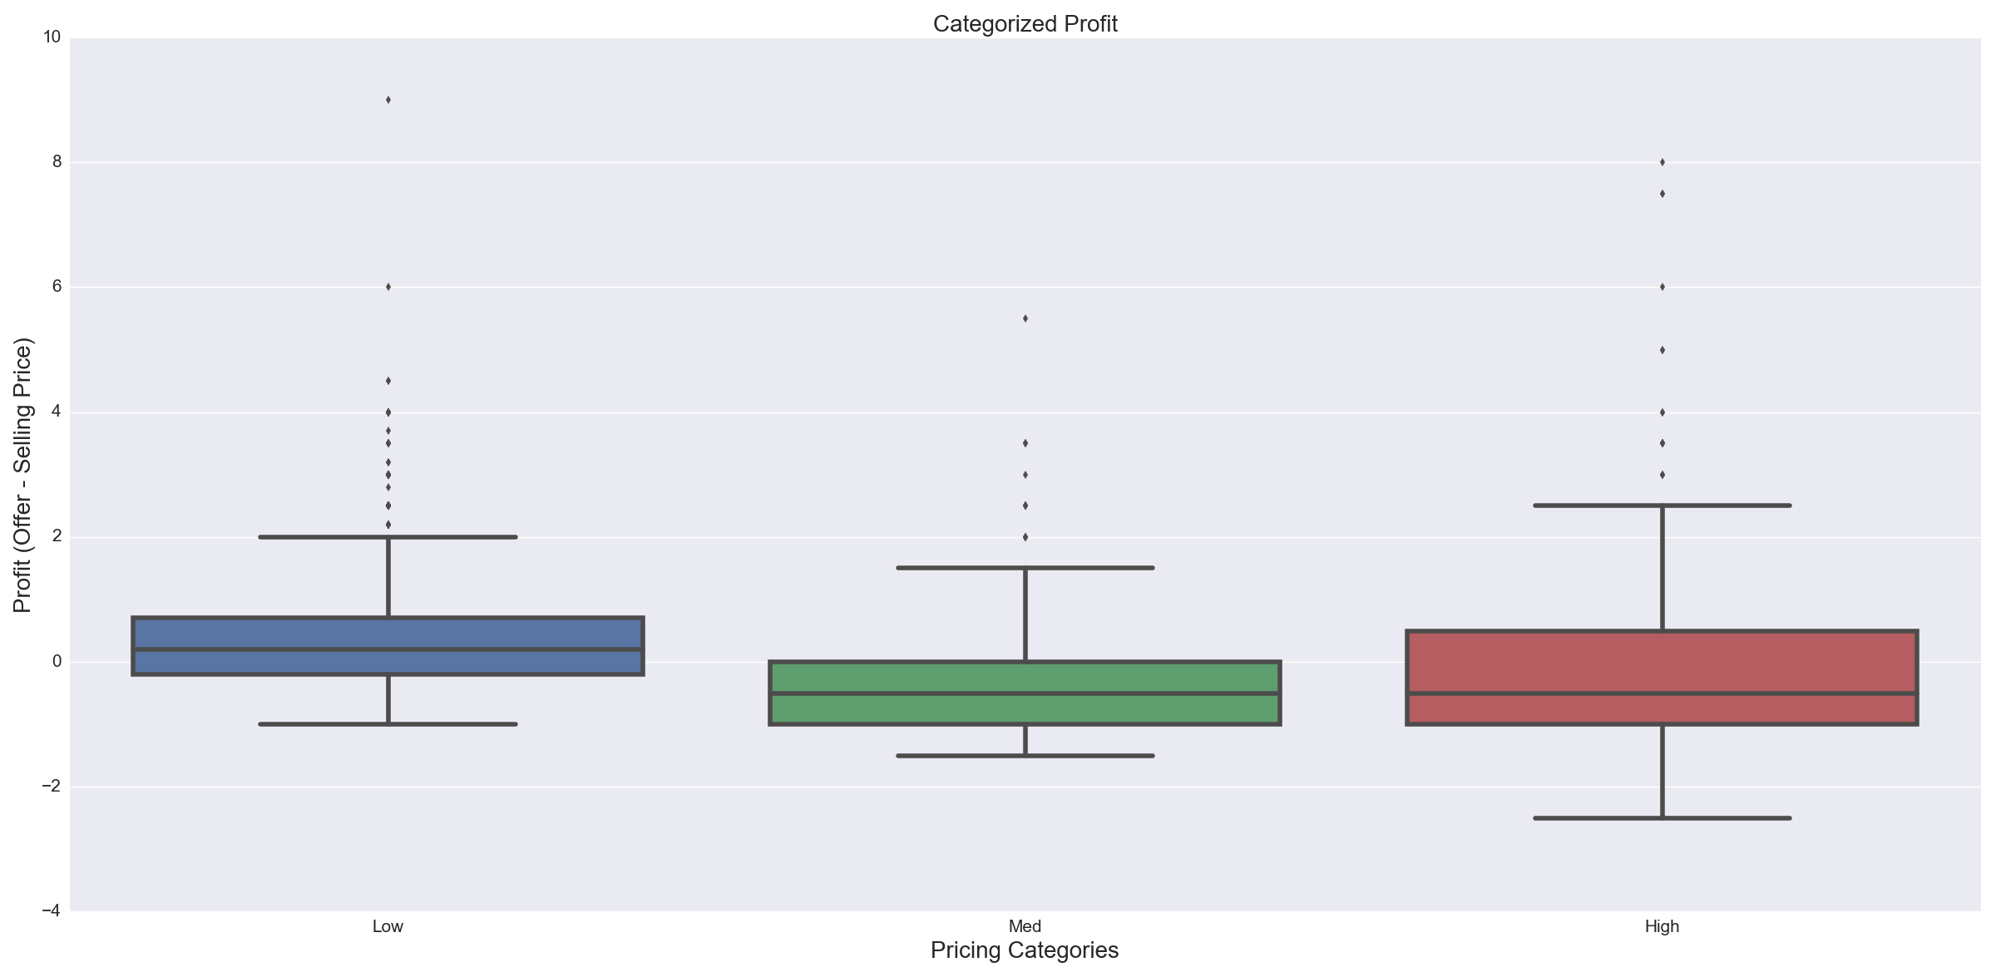

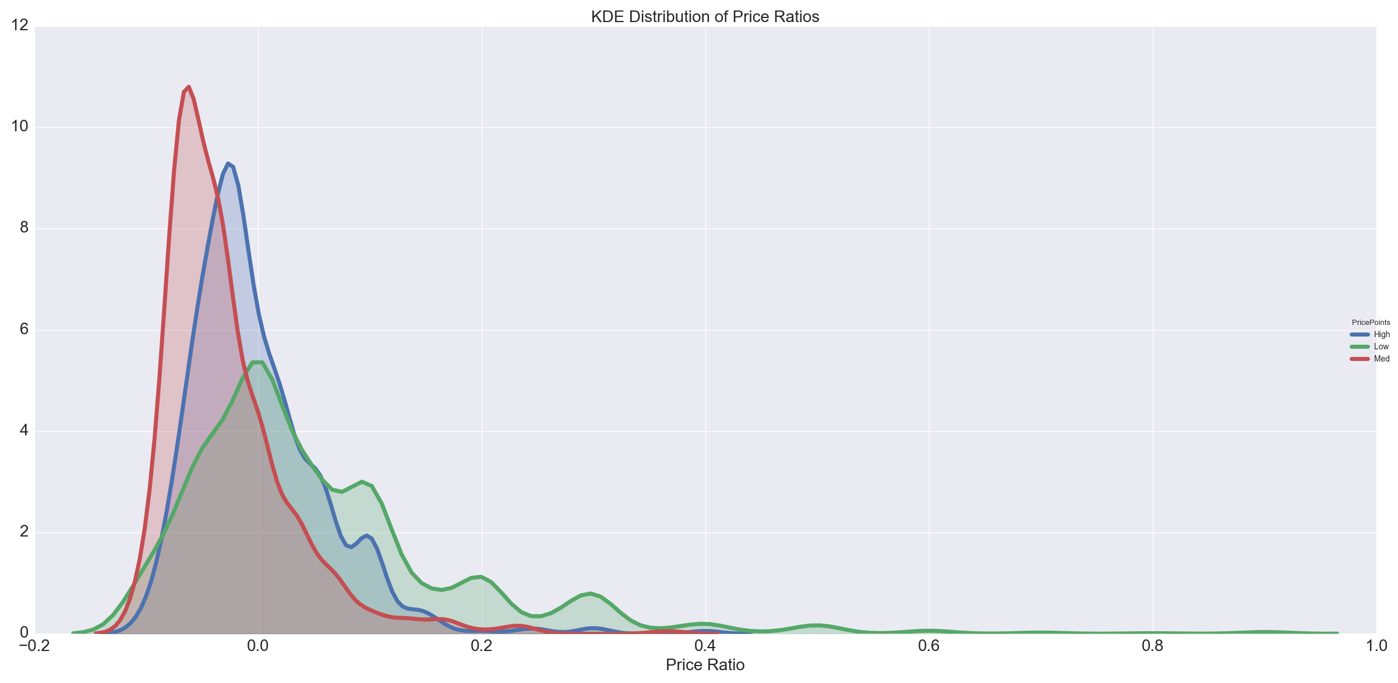As seen above, when profit is categorized into the 3 groups, the profitability of each distinct pricing group becomes clear. Average profit for only Low priced products was non-negative, while average profitability for both Med and High groups were negative. High priced goods had a larger distribution of profitability, which means that the potential for higher flat returns is higher. However, to examine this better, we need to normalize the profit by the actual selling price of the product, as we would hope that as selling price increases, the proportion of profit earned would remain constant.

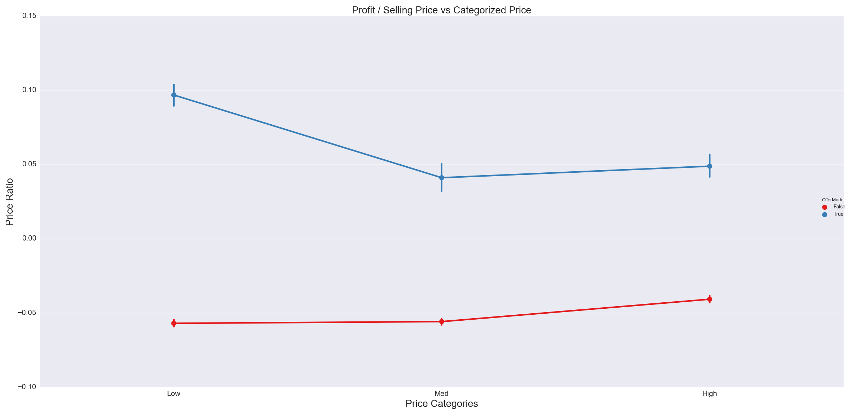However, as shown both above and below, this isn’t the case. The distribution of Price Ratio (Profit/Selling Price) for both Med and High priced products tends to behave as a normal distribution around 0. This means that profitable offers tend to be made around 50% of the time (in actuality, Med priced products are less profitable than High). As you can see below, aggregated Price Ratios however at around 10% for Low priced products for when an offer is made (when Offer > Selling Price) , while Med and High priced product profitability are both around 5%. When an offer is *not* made, profitability tends to be constant throughout the 3 groups, at around -5%.

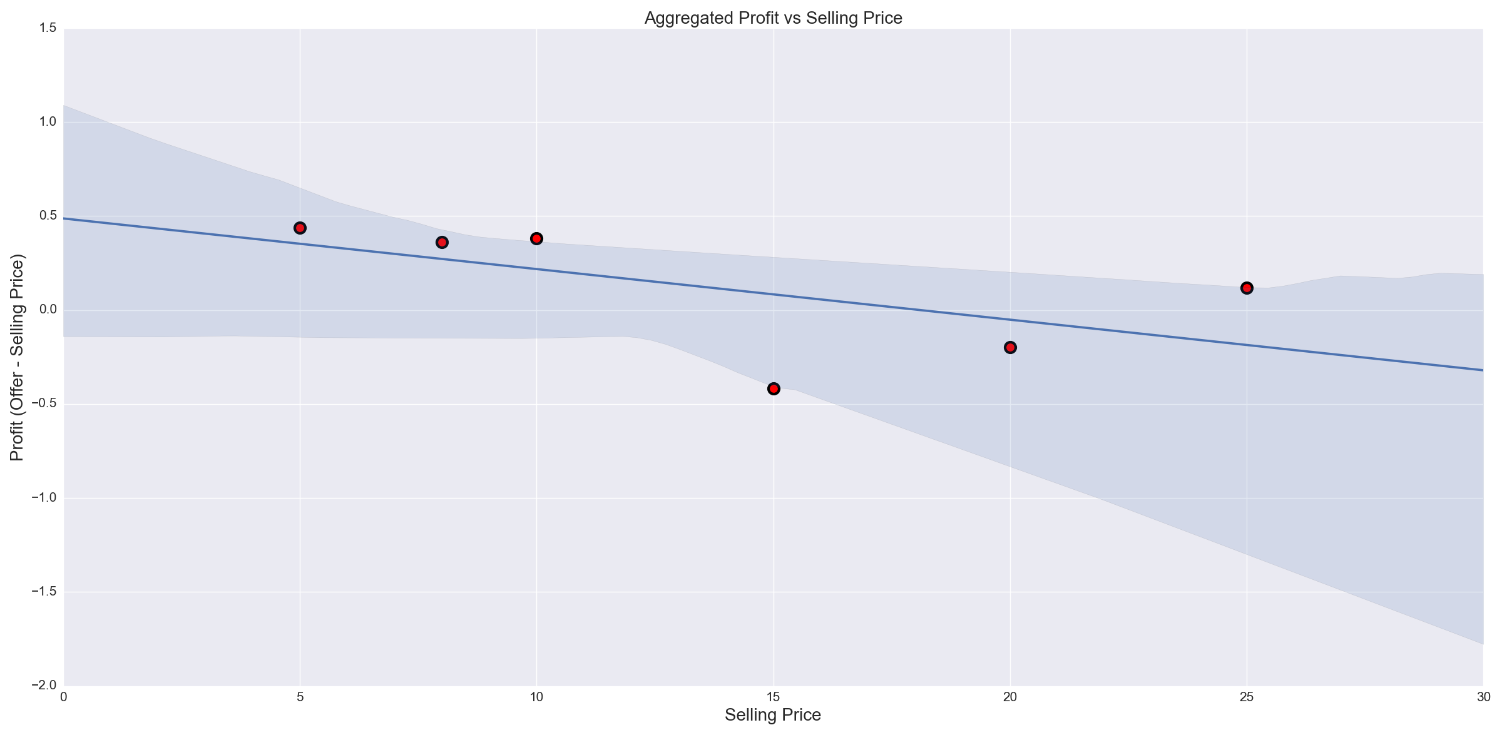A linear regression was made for aggregated profit as a function of selling price, and a clear correlation can be seen, with a R Value of ~-0.6, indicating a strong negative correlation. The P Value however was ~0.22, indicating that the reliability of this correlation will be true only ~78% of the time.

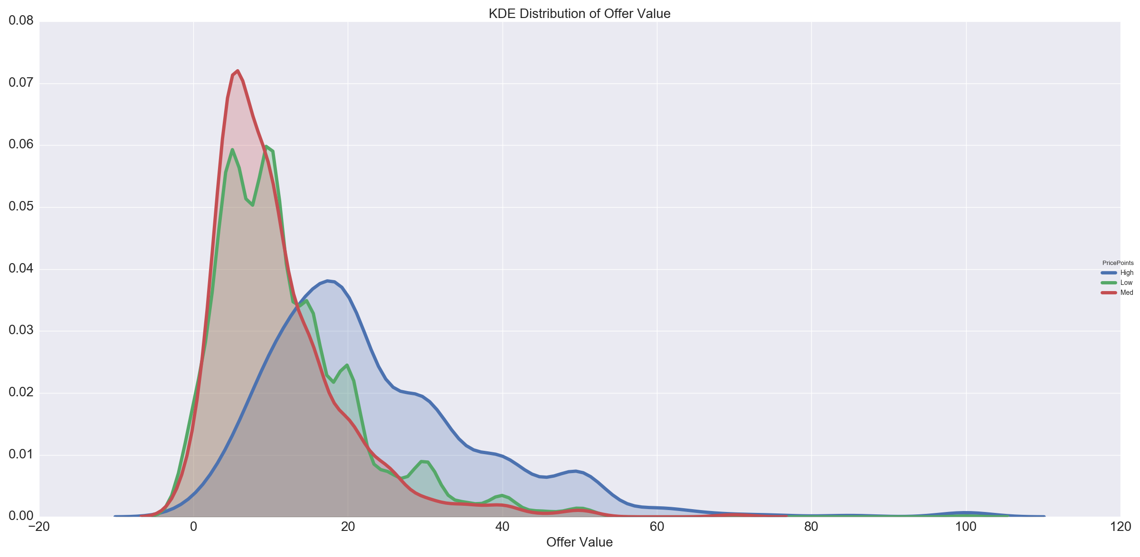Lastly, what is the reason as to why profitability for Low priced items tends to be higher in every regard? The answer to this question lies in the distribution of Offer Values. As you can see below, there is almost a completely identical overlap of Offer Values for Med and Low priced goods, which means that Low priced goods will outperform Med priced goods. This isn’t the case for High priced goods where there is still some overlap, but a larger right-sided distribution, indicating that offers made for higher priced goods has larger volatility.

Summary

My only suggestion at this point is to examine and take in more data. A proper regression is difficult to do when there is a small number of discrete selling points.